EXHIBIT B — FIELD PHOTOGRAPHS
Cheval Club Condominium Association — Roof Investigation

Property: | 1426 N. Orleans Street, Chicago, IL 60610
Prepared for: | Andy Mechavich, President, Cheval Club Condominium Association
Companion to: | Scope of Inquiry exhibit (HDG engagement); item references below point to its Section 5
Date: | May 28, 2026

About these photographs. The following were taken by the Board during the roofing work and after the rooftop decking was lifted for inspection. Captions describe what is shown and note where an interpretation is the Board’s; they are provided to orient the consultant and are not findings. The item references (e.g., “Item E”) correspond to the work items in the Scope of Inquiry.

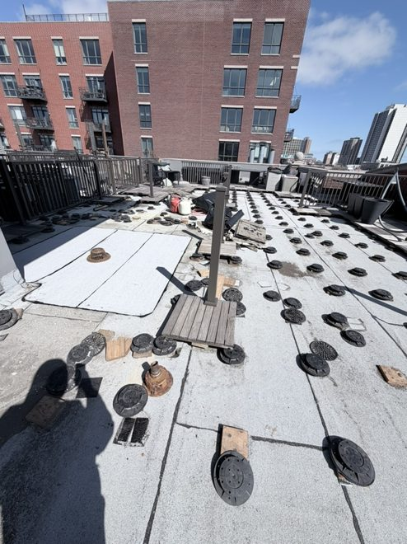  Figure 1. Overall roof — pedestal-mounted paver deck over the granulated SBS modified-bitumen membrane, with cast-iron drains and field seams; decking covers nearly the entire roof. (Items D, G, H) | 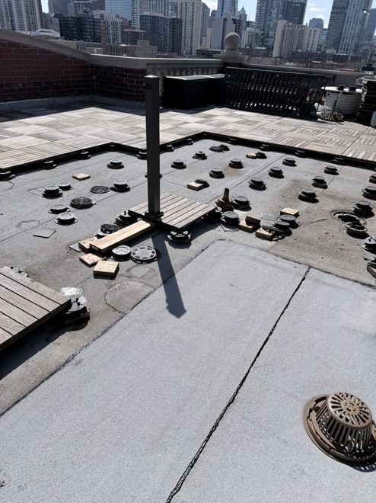  Figure 2. Roof field — pedestal/paver layout, a cast-iron drain with dome strainer (lower right), and a field expansion/seam line. (Items D, H)
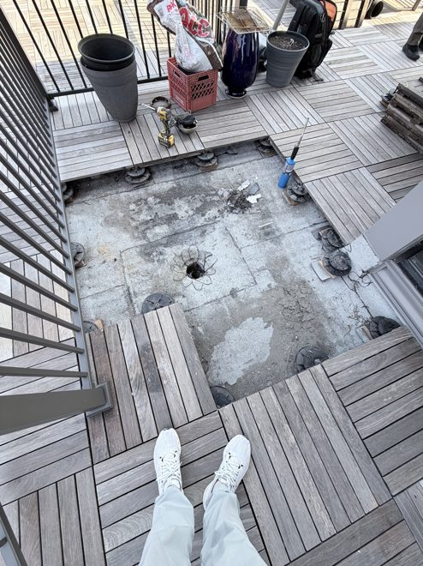  Figure 3. The 2-inch drain (per the Board), decking lifted — the clamping ring/strainer appears unseated and the surrounding membrane is not sumped. (Items E, F) | 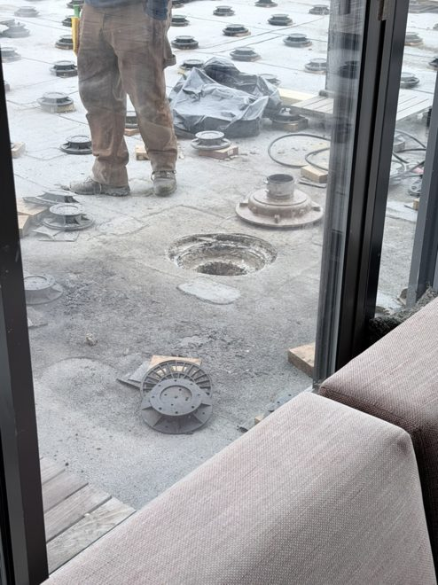  Figure 4. A drain opening set roughly flush with the membrane (no formed sump), with a loose pedestal base alongside, during the work. (Item E)
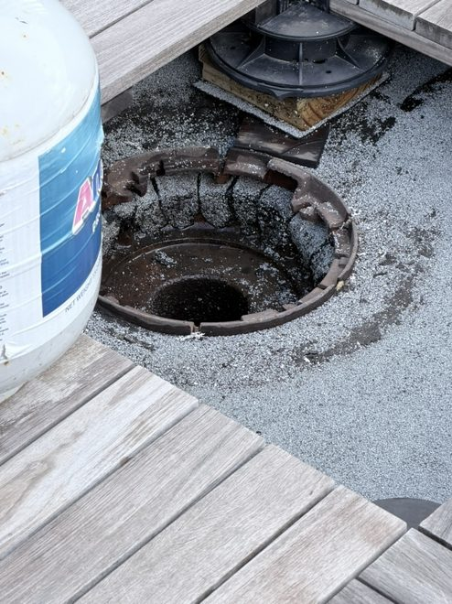  Figure 5. A drain with the cast-iron clamping ring broken into pieces and no dome strainer in place. (Item E) | 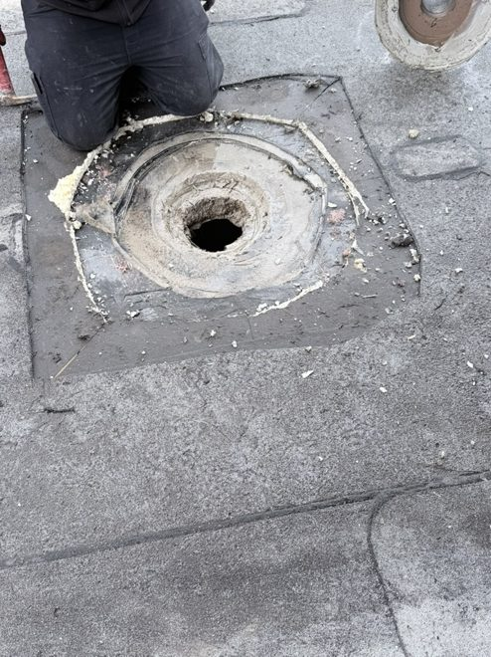  Figure 6. White sealant (“goop”) packed around a penetration; per the Board, associated with a leak at the A/C lines. (Items E, H)
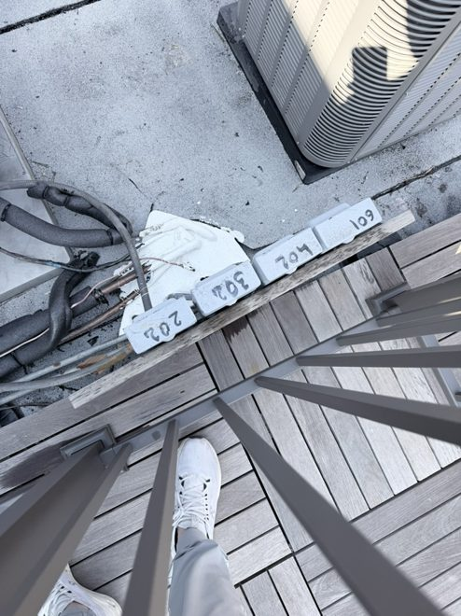  Figure 7. Sealed patches marked by unit number (202, 302, 704, 109), adjacent to A/C condensers and line sets. (Items F, J) | 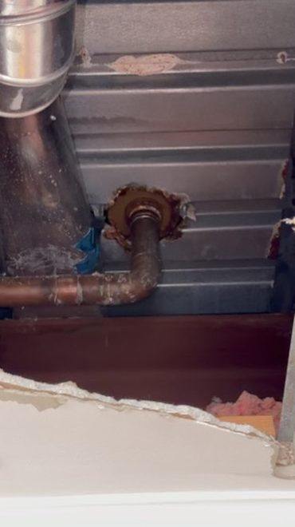  Figure 8. Interior at a pipe penetration through the metal deck — corrosion at the fitting and staining below; per the Board, at the A/C line area. (Item F)
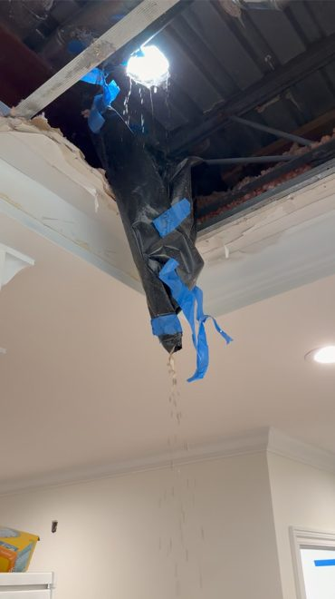
Figure 9. Active interior leak through a ceiling, with temporary plastic sheeting and tape rigged to divert water. (Items F, G)

